Dat-375 Assignment: Addressing the Problem Through Sampling
Karver Stockstill
December 7, 2025

This analysis consists of using a sample size of 10% within the Miami Police Department (MPD), in order to find the top three most frequent crime types in Miami-Dade County. Below are the results of this analysis:
I started with creating a 10 % sample size of the data from the MPD Crime Data Set
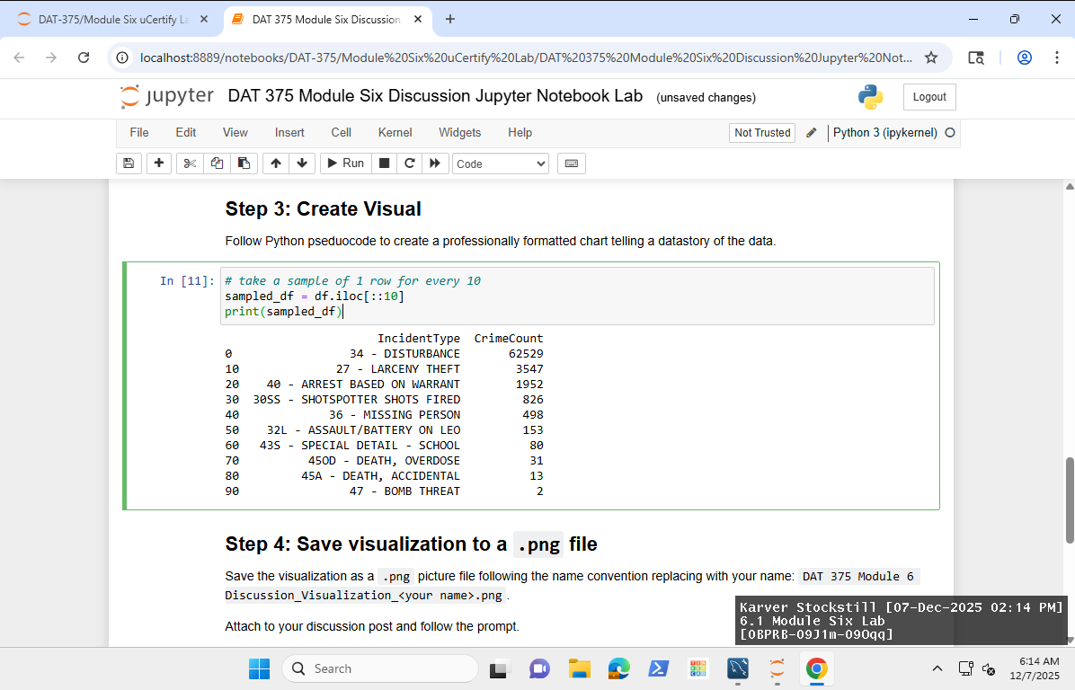
From the sample data that I gathered I created a pivot table to show the top three most frequent crimes within the sample data.
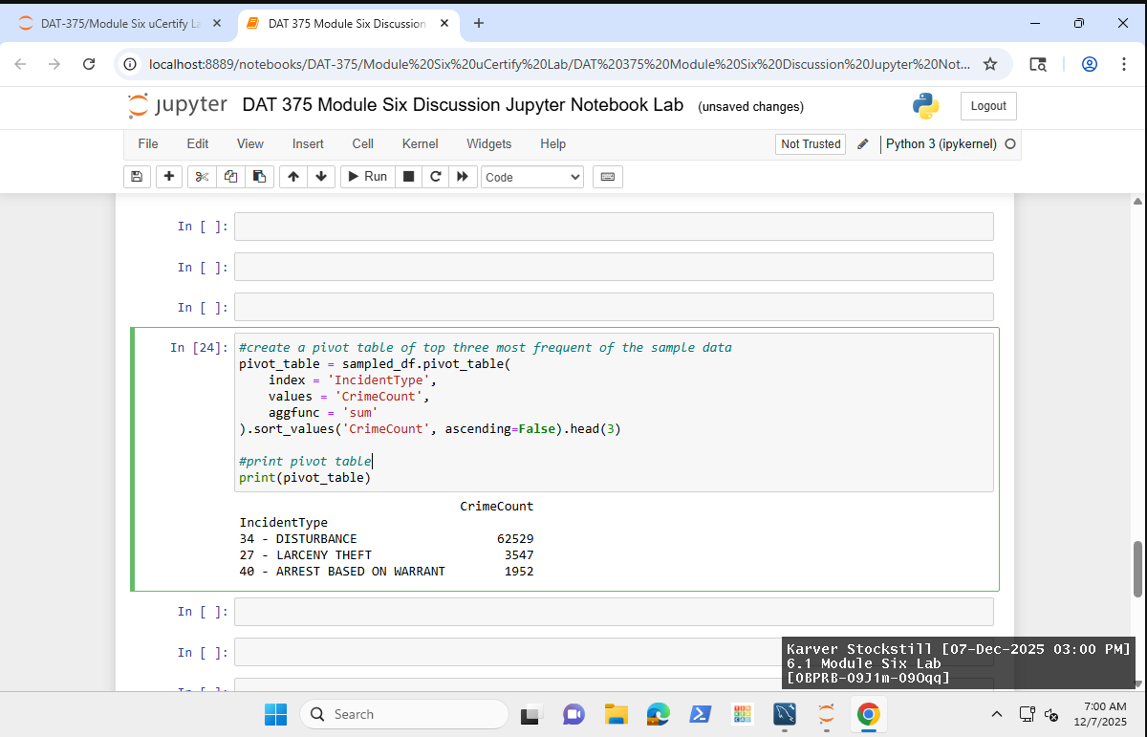
I then created a pivot table from the original MPD Crime Data Set
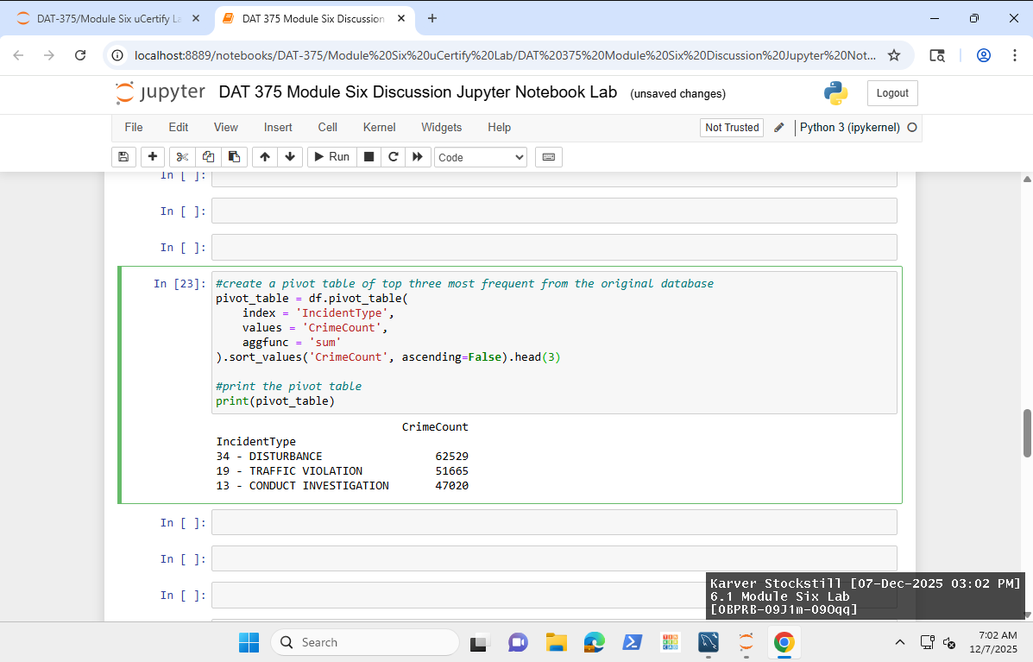

After creating both pivot plots I did side by side comparisons in a pivot table and a bar graph visualization.
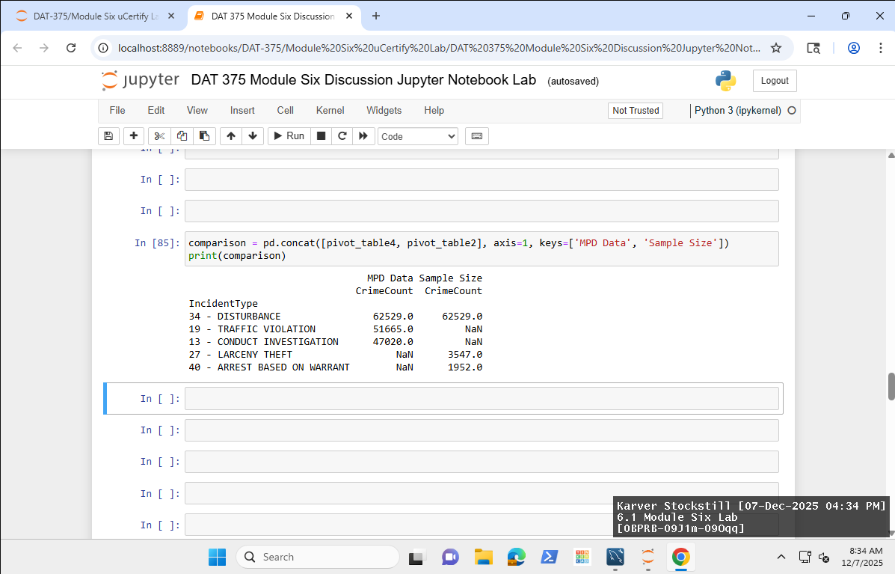
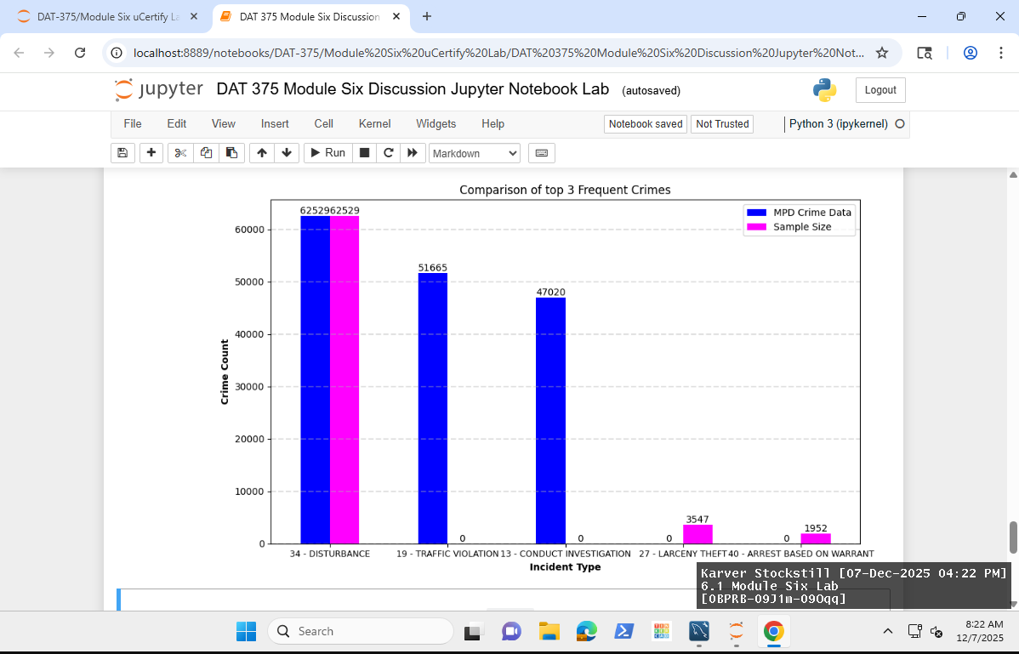

Analysis of the MPD dataset reveals that the three most frequently recorded crimes in the complete data are code 34-DISTURBANCE, 19-TRAFFIC VIOLATION, and CONDUCT INVESTIGATION. In contrast, a 10% sample from the dataset identifies the top three as code 34-DISTURBANCE, 27-LARCENY THEFT, and 40-ARREST BASED ON WARRANT. The expected similarity of DISTURBANCE from both datasets confirms its high frequency in the overall records and its inclusion from the onset of sampling. This pattern confirms that code 34-DISTURBANCE is the most prevalent crime within the MPD records.
The primary difference between the full dataset and the sample size is the ranking of subsequent offenses: while the full dataset ranks TRAFFIC VIOLATION and CONDUCT INVESTIGATION second and third respectively, the sample highlights LARCENY THEFT and ARREST BASED ON WARRANT in these positions. Additionally, the original dataset demonstrates a gradual decline in crime counts, whereas the sample exhibits a sharp decrease—from a high of 62,529 to 3,547, and finally to 1,952—indicating a notable disparity in overall crime volume.
The insights provided by examining the sample underscore certain crime types that may not be as apparent when viewing the full dataset. The bar graph above further illustrates these differences by showing consistently higher crime rates in the full dataset compared to the relative sparsity present in the sample.
We can argue that different results would have occurred if we had created a larger sample size that would have included more significant crimes that are occurring within the area.
Datasets often contain vast amounts of information, which can be difficult to manage or process completely with available systems. In such cases, creating a smaller, more manageable subset of data becomes vital. Sampling methods—whether probability-based or non-probability—depend on the specific question you aim to answer, so identifying your desired outcome is crucial before choosing a sampling approach. Data analysts rely on sampling to draw insights into an entire dataset by examining only a portion (Ronack, 2025). This technique saves time and costs and is especially effective with large datasets, where a well-sized sample accurately reflects the whole. Sampling helps analysts extract insights, build predictive models, and test hypotheses efficiently (Narula, 2023). However, selecting the right sample size is essential; an inappropriate size can skew results and lead to inaccurate conclusions. Overall, sampling enables quicker problem-solving and better understanding of data, supporting informed decision-making.

Resources
Gangwal, Ronack. (2025 January, 09). Types of Sampling and Sampling Techniques. https://www.analyticsvidhya.com/blog/2019/09/data-scientists-guide-8-types-of-sampling-techniques/
Narula, Rashmi. (2023 September, 13). Understanding the Importance of Sampling in Statistics and Data Analytics. https://medium.com/@narula.rashmi888/understanding-the-importance-of-sampling-in-statistics-and-data-analytics-47e58993ea5e

